🔹 Types of Thesauruses
# Source: AI Source: Provided by: [Data Path: Persons Table -> ID Column: 1, Name_En Column: Motasem Essam] -> From: [Chatgpt (GPT-4-turbo)] on [7/29/2025]
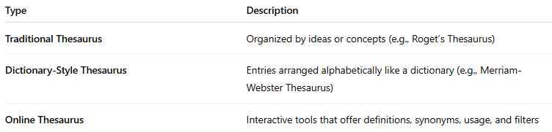
Type | Description
Traditional Thesaurus | Organized by ideas or concepts (e.g., Roget’s Thesaurus)
Dictionary-Style Thesaurus | Entries arranged alphabetically like a dictionary (e.g., Merriam-Webster Thesaurus)
Online Thesaurus | Interactive tools that offer definitions, synonyms, usage, and filters

